Program 1:

#include <iostream>

using namespace std;

void traverse(int arr[], int n){

for(int i=0; i<n; i++){

cout << arr[i] << " ";

}

cout << endl;

}

void merge(int arr[], int low, int mid, int high){

int temp[high - low + 1];

// cout << "size=" << (high-low+1)<< endl;

mid = mid + 1;

int l = low, m = mid, h = high;

// cout << low << " " << mid << " " << high << endl;

int i=0;

while(l<mid && m<=high){

if(arr[l] > arr[m]){

// cout << "low>mid mid="<<m <<endl;

temp[i++] = arr[m++];

}else{

// cout << "low<mid low="<<l <<endl;

temp[i++] = arr[l++];

}

}

while(l<mid){

// cout << "inside norml while low="<<l <<endl;

temp[i++] = arr[l++];

}

while(m<=high){

// cout << "inside norml while mid="<<m <<endl;

temp[i++] = arr[m++];

}

// cout<<"temp=";

// traverse(temp, high - low + 1);

int k = 0;

for(int j=low; j<=high; j++){

arr[j] = temp[k++];

}

// traverse(arr, 5);

}

void mergeSort(int arr[], int low, int high){

if(low < high){

int mid = (high + low)/2;

mergeSort(arr, low, mid);

mergeSort(arr, mid+1, high);

merge(arr, low, mid, high);

}

}

int main()

{

int n;

cin >> n;

int arr[n];

for(int i=0; i<n; i++){

cin >> arr[i];

}

// int arr[5] = {5,4,3,2,1};

// int n = 5;

traverse(arr, n);

mergeSort(arr, 0, n-1);

traverse(arr, n);

return 0;

}

Output:

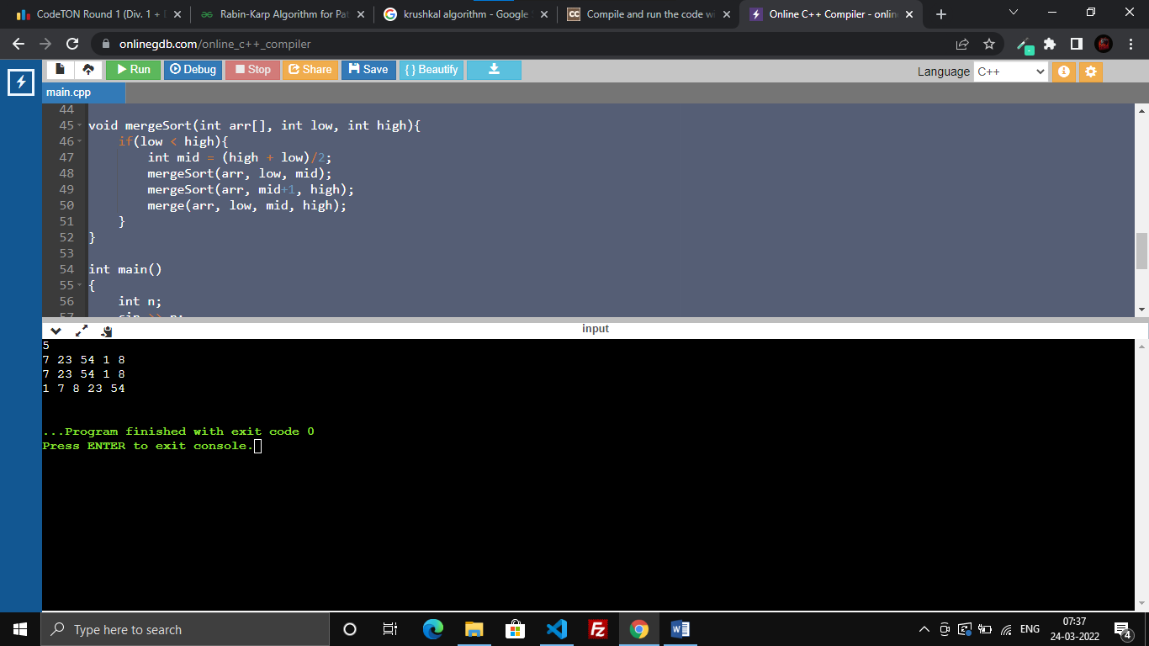

Program 2:

#include <bits/stdc++.h>

using namespace std;

void traverse(int arr[], int n){

for(int i=0; i<n; i++){

cout << arr[i] << " ";

}

cout << endl;

}

int partition (int arr[], int low, int high, int size)

{

int pivot = arr[high];

int i = (low - 1);

cout << "inside partition: \n";

for (int j = low; j <= high - 1; j++)

{

if (arr[j] < pivot)

{

i++;

swap(arr[i], arr[j]);

}

traverse(arr, size);

}

swap(arr[i + 1], arr[high]);

traverse(arr, size);

return (i + 1);

}

void quickSort(int arr[], int low, int high, int size){

if (low < high)

{

int pi = partition(arr, low, high, size);

quickSort(arr, low, pi - 1, size);

quickSort(arr, pi + 1, high, size);

}

}

int main()

{

int n;

cin >> n;

int arr[n];

for(int i=0; i<n; i++){

cin >> arr[i];

}

cout<<"Inputed Array is:";

traverse(arr, n);

quickSort(arr, 0, n-1, n);

cout<<"Sorted Array is:";

traverse(arr, n);

}

Output:

